**DEPARTMENT OF**

**ELECTRONICS AND COMMUNICATION ENGINEERING**

**College of Engineering and Technology, SRM IST.**

MINI PROJECT REPORT

ODD Semester, 2022-23

Lab code & Name : 18ECC102J Electron Devices Lab

Year & Semester : II Year, III sem

Project Title : INFRARED RADIATION FIRE DETECTOR

Lab Supervisor **:** Dr. Sudhanya P

Team Members : RA2111004010007 - ROHAN GARG

RA2111004010010 – ANKUR KUMAR

RA2111004010039- DEV KHETAN

|  |  |  |  |
| --- | --- | --- | --- |
| Reg. No |  |  |  |
| Mark split up |
| Novelty in the project work  (1 marks) |  |  |  |
| Level of understanding of the design formula (2 marks) |  |  |  |
| Contribution to the project  (1 Marks) |  |  |  |
| Report writing (1 Marks) |  |  |  |
| **Total (5 Marks)** |  |  |  |

Date:

**Signature of Lab Supervisor**

**INFRARED RADIATION FIRE DETECTOR**

**OBJECTIVE**

An Infrared radiation fire detector which can be used to detect flames will turn ON the LED light after a flame/fire is detected .

**ABSTRACT**

An Infrared radiation fire detector which can be used to detect flames . The circuit makes use of an IR receiver which gives a repeated high and low output when it receives infrared light. Infrared radiation is used in a wide variety of applications, and new applications are constantly being developed. A typical system for detecting infrared radiation is usually configured as shown below.



**INTRODUCTION**

Since infrared light has a higher wavelength than our eyes can see so we are not able to sense it however it can be seen clearly using a camera. The flame monitor is used for detecting light emitted from flames and for observing how the flames are burning. Light emitted from flames is distributed widely from the UV region to the infrared region. Detection methods include using a PbS photoconductive detector to detect infrared light, using a two-color detector (K1713-01) to detect a broad spectrum from the UV region to the infrared region, and using PbSe and pyroelectric detectors to detect a wavelength of 4.3 µm.

**HARDWARE REQUIREMENT/DESCRIPTION**

• 1x IR receiver (TSOP) • 1x bc557 transistor • 1x 10uf capacitor • 1x 1K resistor • 1x 220 ohm resistor • 1x LED etc

**CIRCUIT/COMPONENT SPECIFICATIONS**

|  |  |
| --- | --- |
| Supply voltage (*V*CC) | 3 to 12 V |
| Supply current (*V*CC = +5 V) | 3 to 6 mA |
| Output current (maximum) | 200 mA |
| Power consumption (minimum operating) | 30 mW@5V |
| [Operating temperature](http://en.wikipedia.org/wiki/Operating_temperature) | 0 to 70 °C |

**CIRCUIT DIAGRAM**

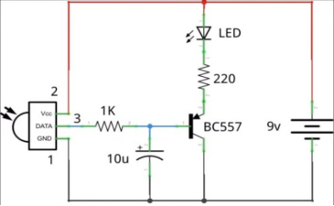

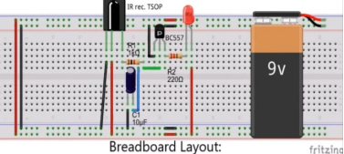

**DESIGN ISSUES**

* Maximum supply voltage should not exceed 12V
* Humidity should not exceed 75% relative humidity.
* Timing tolerance should not exceed +10 sec for 1 min.

**APPROACH/METHODOLOGY**

The scope is to detect FIRE inside the house that will inform the user immediately if fire has been detected. The study will cover a limited area only or indoors and narrow areas like school hallways, office rooms, and school classrooms. The possible clients of this study, generally, are the public because it is not limited to specific people with the profession but it can be used by everyone that needs it inside their homes and offices. The study is limited to detecting fire only whether it is fire-causing cooking, vaping, smoking .

**CONCLUSIONS**

The study developed a system that detects the presence of smoke automatically and tells the user about the detected smoke by using the LED

**REFERENCES**

<https://www.researchgate.net/>

**APPENDIX**

**IR receiver (TSOP)**

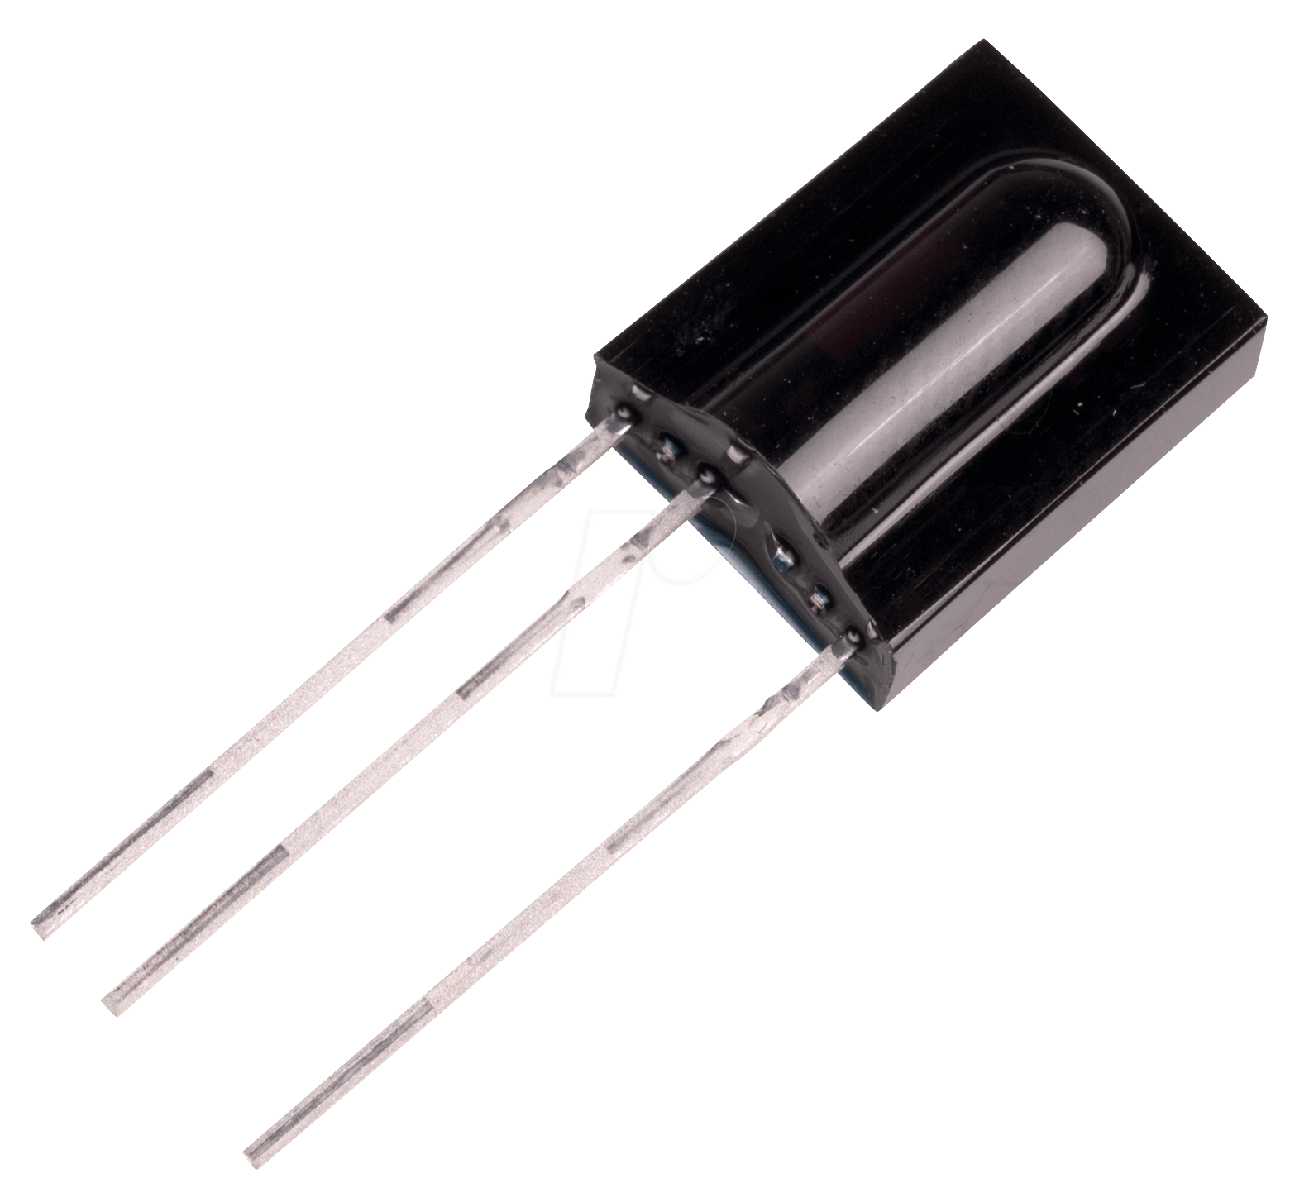

The tsop1738 is a infrared receiver tuned to react only to ir of frequency 38 khz. This ir sensor module consists of a pin diode and a pre amplifier which are embedded into a single package. The output of tsop is active low and it gives +5v in off state..

**LED**

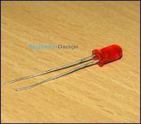

LEDs are Light Emitting Diodes. They are super compact and do not emit heat ; most commonly used in emergency lightings, automotive tail lights.

**bc557 transistor**

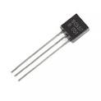

BC557 is a general-purpose transistor, used like an amplifier or a switch in electronic circuits. Its hFE ratings of this transistor range from 125 to 800 to make the transistor ideal by using like an amplifier within electronic circuits like audio signal amplification.

**CAPACITOR ( 10 UF )**

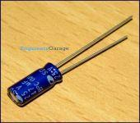

Capacitor is a passive component used to store charge. The charge (q) stored in a capacitor is the product of its capacitance (C) value and the voltage (V) applied to it. Capacitors offer infinite reactance to zero frequency so they are used for blocking DC components or bypassing the AC signals.

**• 220 ohm resistor 1K resistor**

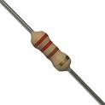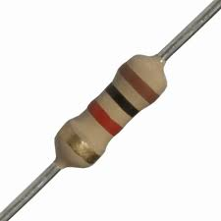

A resistor is a passive two-terminal electrical component that implements electrical resistance as a circuit element.

**INFRARED RADIATION FIRE DETECTOR**

**GROUP MEMBERS**

**RA2111004010007 - ROHAN GARG**

**RA2111004010010 – ANKUR KUMAR**

**RA2111004010039- DEV KHETAN**

PHOTO OF TEAM MEMBERS WITH EXPERIMENTAL KIT IN WORKING CONDITION



